**Interface Design and Ethos – Team 11**

**House Style/Ethos for Implementation –**

When considering how our interface would look for our implementation, we agreed as a team on the software’s aesthetics for the end user, as well as the general style that could be further applied to any documentation and future software with the same target audience. We decided that as the software we were designing had a very specific niche, to be used in a purely professional manner, and for very limited amounts of time, there was no need to make it particularly flashy or eye catching. It merely had to be easy on the eye, with all the features clear to the end-user to enable swift, user-friendly operation.

**Usability –**

The main consideration when creating our interface is the usability of the software to the end-user. Since our software isn’t that complex in its functionality, a lot of the user functions can be displayed instantly on opening the application. We don’t have any need to obscure features behind multiple introductory pages, so a simple login page that leads into all the functions would suffice. A lot of our implementation is “under the hood” so to speak, things such as the way students are assigned does not need to be visible to the user and they only need to see the input, and result. In theory, all the user needs to do is login 🡪 see available functions 🡪 user function 🡪 see result. We may have to create a pop up window to display longer lists.

**Accessibility –**

We had to decide on, based on the features of the implementation, how we would lay out the functionality and how we would split up features. Upon evaluation of the tasks the software would perform, it was clear to see the simplest way to split up the functionality was to have the user interface in two distinct sections, dealing with tutors and students separately. We are striving for consistency here, so both sections should look and operate essentially the same (besides the actual under-the-hood features), so once user has learned one they have already learned the other. Every action the user makes should have clear feedback and be obvious that a task has completed successfully, or failed. We would ideally also like a feature that aids easy reversal of actions by essentially reverting anything the user has done in their current session, and returning the software to a “blank” state. The output of any function should be fully-featured with enough information that the user needs, but not overly obscure or complicated. Commands should function the same for both sections.

**Data Display –**

Due to the professional, simple-yet-powerful nature of the software, we want to make the software very concise and obvious in its display of data. The base functions should be clearly titled in a larger, bolder font, with all interactive elements encased in a button or with consistent markup so the user instantly knows what is usable and what is text. Colour should be the same throughout with no bright or too-dull colours so readability is maximised (this may be more relevant to usability).

**Data Entry –**

A key feature of having usable, enjoyable software, is the way the user enters the data they need operating on. Both sections of the software should be utterly consistent on what the user inputs as they functionally do not require differing inputs. In our case, all we need is an input box for the student/tutor details (We can implement parsing features that can tell whether a name or ID number is entered), a combo box to decide the action to be undertaken on the details, and a button to perform said action. This allows us to be flexible in what the user enters an the action performed, and scalable as we can easily add more functions to the combo box and more parsing features to allow different things to be entered.

**Interface –**

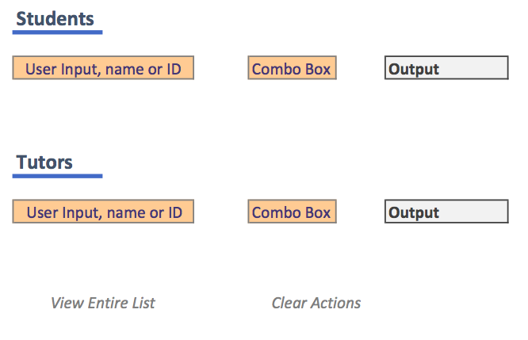

Show Student Details, Assign Tutor, Re-Assign Tutor, Delete Student

Display Tutees, Display Quota, (Flag as unavailable?)

**View Entire List –** Feature to view the raw CSV/Excel data of the Personal Student database, perhaps with a certain access level or for power-users only.

**Clear Actions –** Clear any information onscreen and reset program to “default” state.